**Phase 5**

**PROJECT DOCUMENTATION& SUBMISSION**

|  |  |
| --- | --- |
| **Date** | **31-10-2023** |
| **Team ID** | **678** |
| **Project Name** | **Personal Blog on IBM Cloud Static Web Apps** |

**Problem Statement**

Create a personal travel blog hosted on IBM Cloud Static Web Apps. Share your travel adventures, tips, and captivating photos with the world. Use IBM Cloud Static Web Apps to easily update your blog and document your journeys.

**Introduction:**

# Traditional server-based applications are giving way to modern, serverless architectures, and IBM Cloud is at the forefront of this revolution. IBM Cloud Static Web Apps is a powerful tool that enables developers to build, deploy, and scale web applications with unprecedented ease and efficiency. In this personal blog, we'll take you on a journey to explore the world of IBM Cloud Static Web Apps and its potential to redefine your web development experience.

**LITERATURE SURVEY**

**1.“ CLOUD COMPUTING IN TOURISM”,Vipin Nadda [2020]**

With rapid growth and development in technology, cloud computing has become dominant platform for small businessesas well as majorenterprises. Cloudcomputing streamlines the overall delivery of services and resources, helps keeping the costs in control, and global business is set for a huge change in the way businesses are done.

**2. “DESGIN OF SMART TRAVEL MANAGEMENT ”, Fang Gao [2021]**

The speed of development of tourism in our country is very fast. Some cities have achieved very good results in the development of tourism, which has led to the development of the local economy. In accordance with its own reality, a city strives to create a distinctly distinctive tourism economic model that effectively serves the people.Against this backdrop, this article has conducted in-depth analysis and research on the development of tourism in the city, and put forward the idea of designing a smart tourism management system based on cloud.

**3. “MINING TOURISM OPINION ON POPULAR INDIA James A. Pruneski [2020]**

User-generated content is an exploration area of interest with regards to web 2.0. The development of social networks and community-based websites have changed the manner in which individuals utilize the Internet. It makes individuals no longer restricted to pursuing the data given by professional channels, but to making individual profiles, producing personalized content, or sharing photographs, recordings, blogs, and so forth. This sort of data comprises the current online user-generated content. With the continuous development of the travel industry, the quantity of online travel review websites has also increased. Indian Tourism is popular for its rich culture and diversity and hence Government of India has increased the number of new tourist destinations to expand their popularity and presence. Researchers have proposed various studies to increase tourism network using Big Data. Techniques of Sentiment Analysis along with Topic Modelling have been used to unearth patterns and observations from online reviews.

**4. “TOURISM CLOUD MANAGEMENT SYSTEM” ,Ebuka Ibeke [2020]**

Destinations like China are primed for successful performance in incoming tourism, with China set to overtake France as the leading destination worldwide by 2030 [1]. Similarly, tourism in the city of Mumbai, India, also increases yearly. Between 2009 and 2017, Mumbai saw an increase of 10.6%— the second highest growth rate in tourism for European tourists. Te World Travel Awards awarded India and Mumbai the ‘Best Destination’ and ‘Best Destination City’, respectively, in 2018. However, China is primed to take over this position. As tourism steadily grows, so does the use of smartphones.

**5. “IMPROVISING TRAVEL RECOMMENDATION”, Xlong Yin[2022]**

A travel recommendation system based on social media activity provides a customized place of interest to accommodate user-specific needs and preferences. In general, the user’s inclination towards travel destinations is subject to change over time. In this project, we have analyzed users’ twitter data, as well as their friends and followers in a timely fashion to understand recent travel interest.

**DESIGN THINKING**

In my case, the end-users were people who would visit my web app. To understand their needs and expectations, I conducted user interviews, surveyed potential users, and analyzed competitors' websites. This helped me gain insights into what features and content would be most valuable to my audience.

**Define:**

With a clearer understanding of the users' needs, I moved on to defining the problem statement and project goals. I established the core purpose of my static web app and identified the key functionalities it needed to have. Defining these parameters helped provide a clear direction for the project.

**Ideate:**

In the ideation phase, I brainstormed ideas for the web app's design and content. I used techniques like mind mapping and brainstorming sessions to generate creative solutions. This phase was all about thinking outside the box and considering different approaches to tackle the problem.

**Prototype:**

With a bunch of ideas in hand, I created a low-fidelity prototype of the web app. This prototype allowed me to visualize the layout, navigation, and overall user experience. I used wireframing tools and collaborated with colleagues and friends to get feedback on the initial design.

**Test:**

Testing is a crucial step in the Design Thinking process. I conducted usability tests with potential users to gather feedback on the prototype. This step helped me identify usability issues, pain points, and areas for improvement. It also confirmed that I was heading in the right direction and meeting the users' needs.

**Build:**

After refining the prototype based on user feedback, it was time to start building the static web app on the IBM Cloud platform. I selected the technology stack and tools that best suited my project's requirements. This phase involved coding, designing, and content creation. I kept the design thinking principles in mind throughout the development process, ensuring that the final product was user-centric.

**Launch and Iterate:**

The final step was to launch the static web app. After the launch, I continued to gather user feedback and monitor analytics to identify any issues or areas for improvement. This iterative approach allowed me to make continuous enhancements to the web app and ensure it remained aligned with user expectations.

**PLATFORM SELECTION:**

* Choose a platform like WordPress, Blogger, Wix, or another of your preference.
* Consider factors such as ease of use, customization options, and your technical proficiency.

**2. Domain and Hosting:**

Register a domain name related to your travel blog.

Set up hosting (unless you're using a platform that offers hosting).

**3. Layout and Design:**

**Design plays a crucial role in the success of your travel blog. Consider the following elements:**

**Header:**

Create a personalized logo or title for your blog.

Include a navigation menu with sections like "Home," "Destinations," "Blog," "About," and "Contact."

**Homepage:**

* Showcase a visually appealing hero image or slideshow of your travel experiences.
* Include a brief introduction about your blog's theme and purpose.
* Display a featured blog post or highlight your latest adventures.

**Blog Page:**

* Organize your blog posts in a clean and easily navigable grid or list.
* Include an attractive featured image for each post.
* Implement a search bar and category/tags filters for better content discovery.

**Destination Pages:**

* Create separate pages for different travel destinations.
* Include high-quality photos, descriptions, travel tips, and itineraries for each location.

**About Page:**

* travel philosophy, and background.
* Include a high-quality photo of yourself.

**Contact Page:**

* Provide a contact form for readers to get in touch with you.
* Include links to your social media profiles.

**Footer:**

* Display a copyright notice, privacy policy, and links to important pages.
* Include a subscription form for your newsletter.

**TECHNOLOGY ARCHITECTURE**

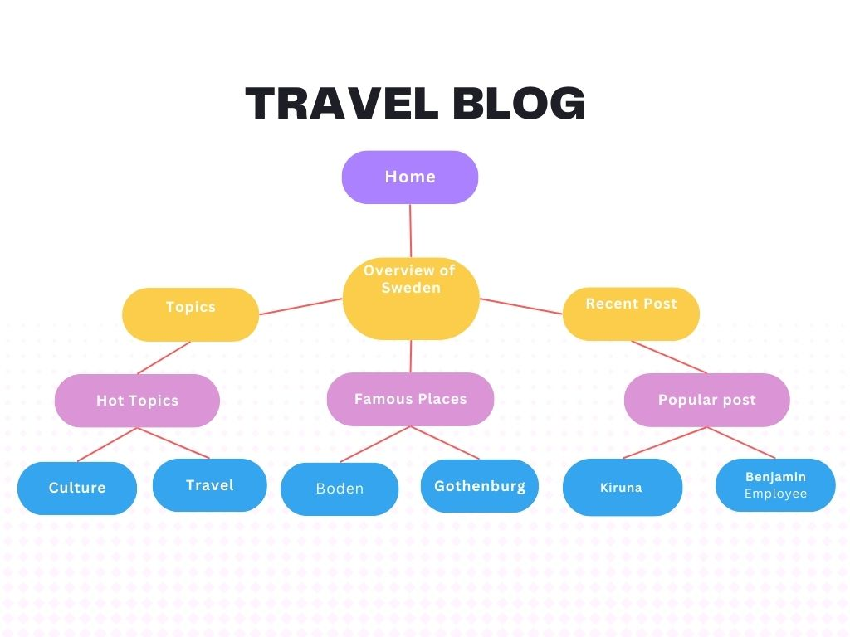

**PROJECT DEVELOPMENT STEPS AND SCREENSHOT**

**CODING:**

**3.HTML File**

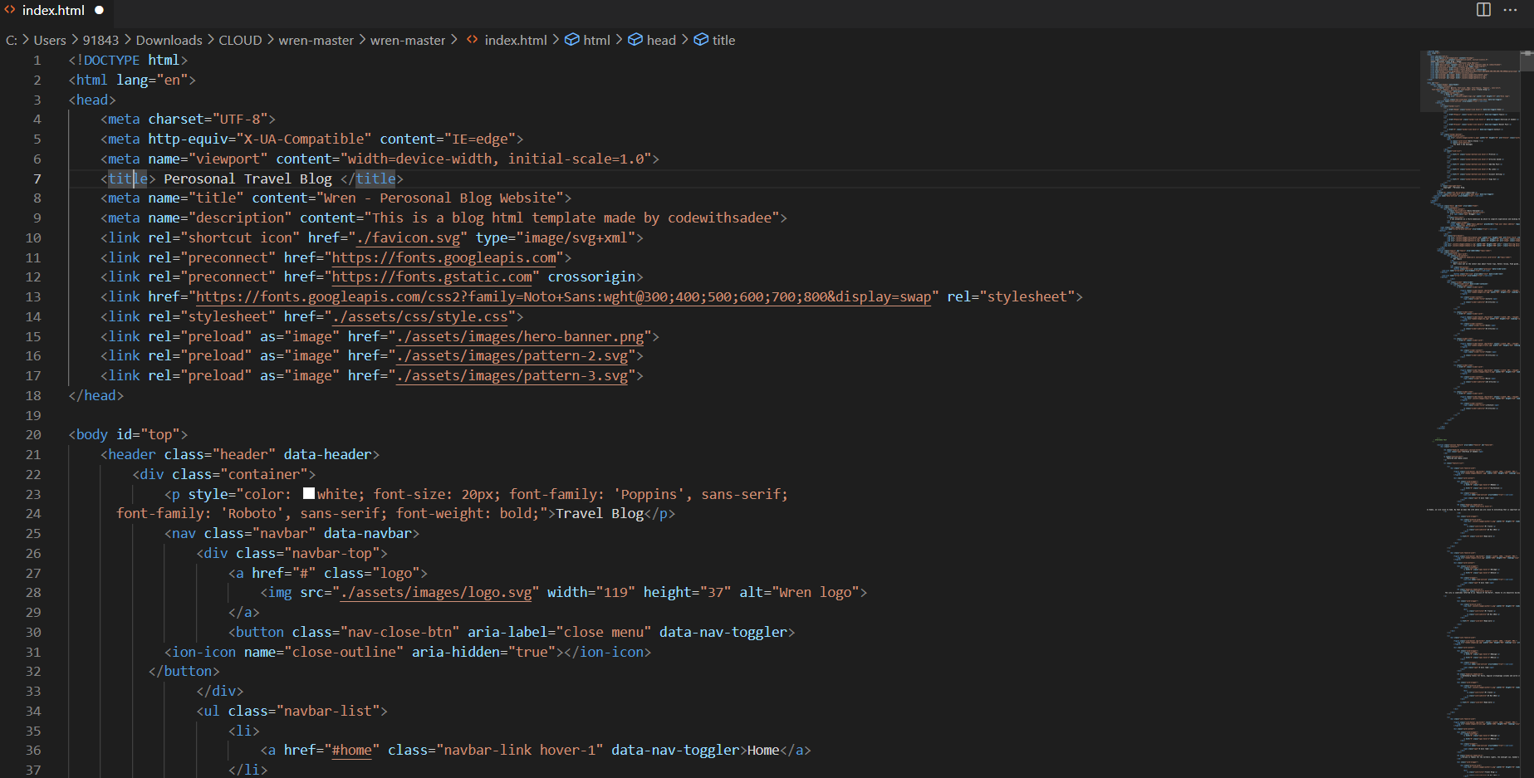

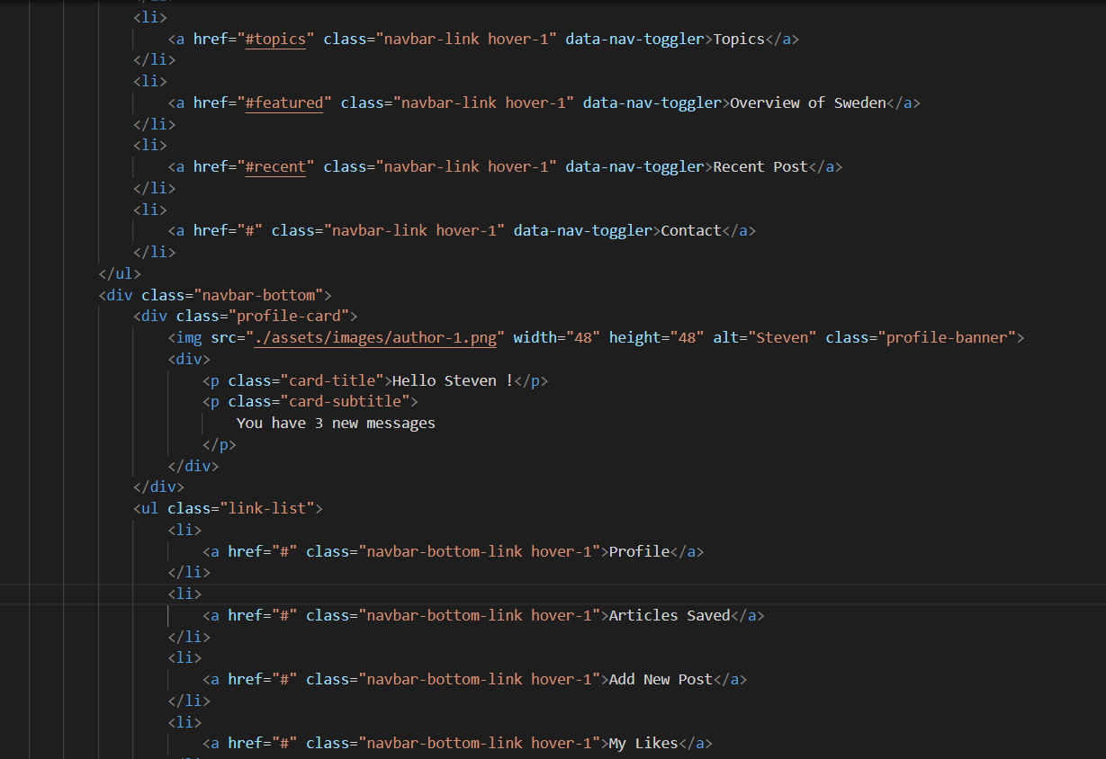

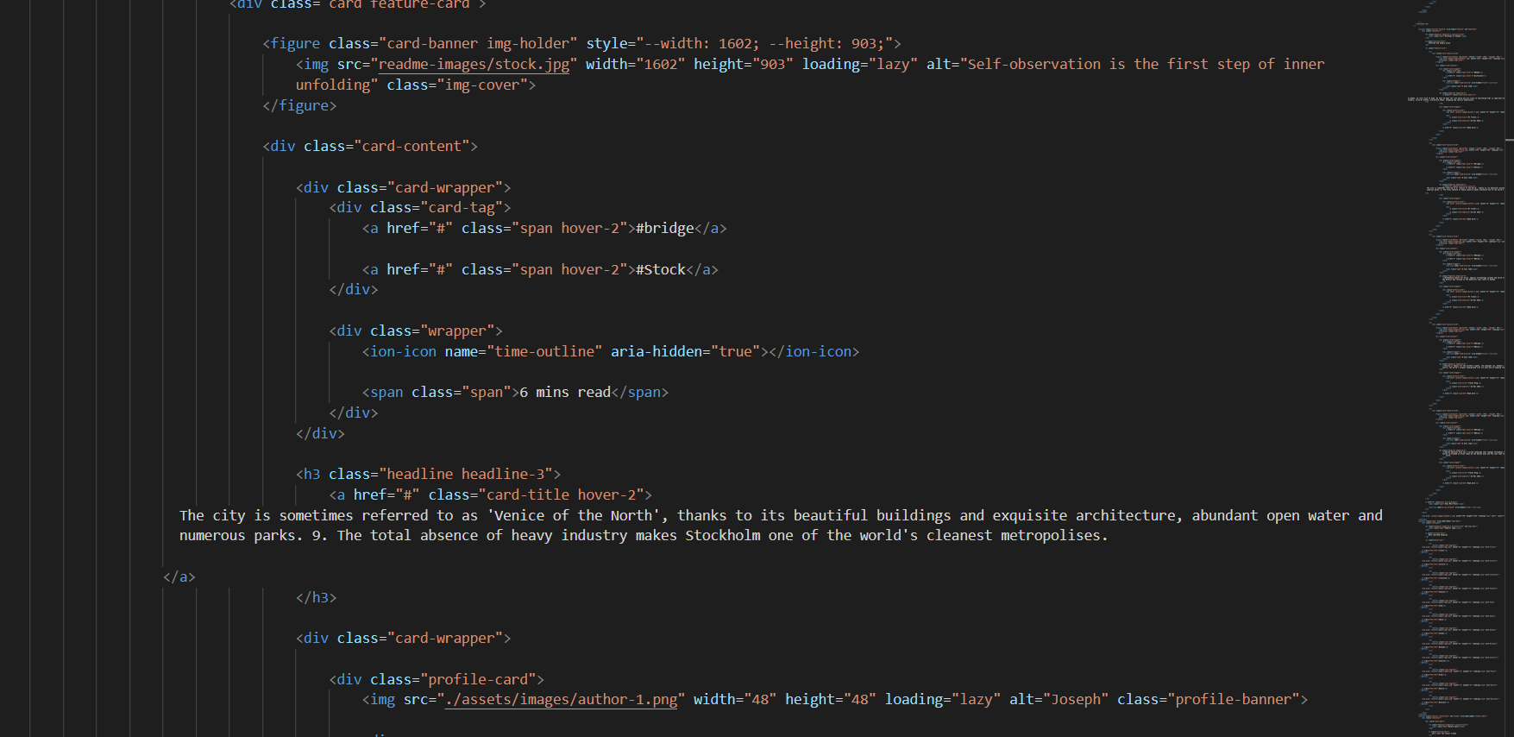

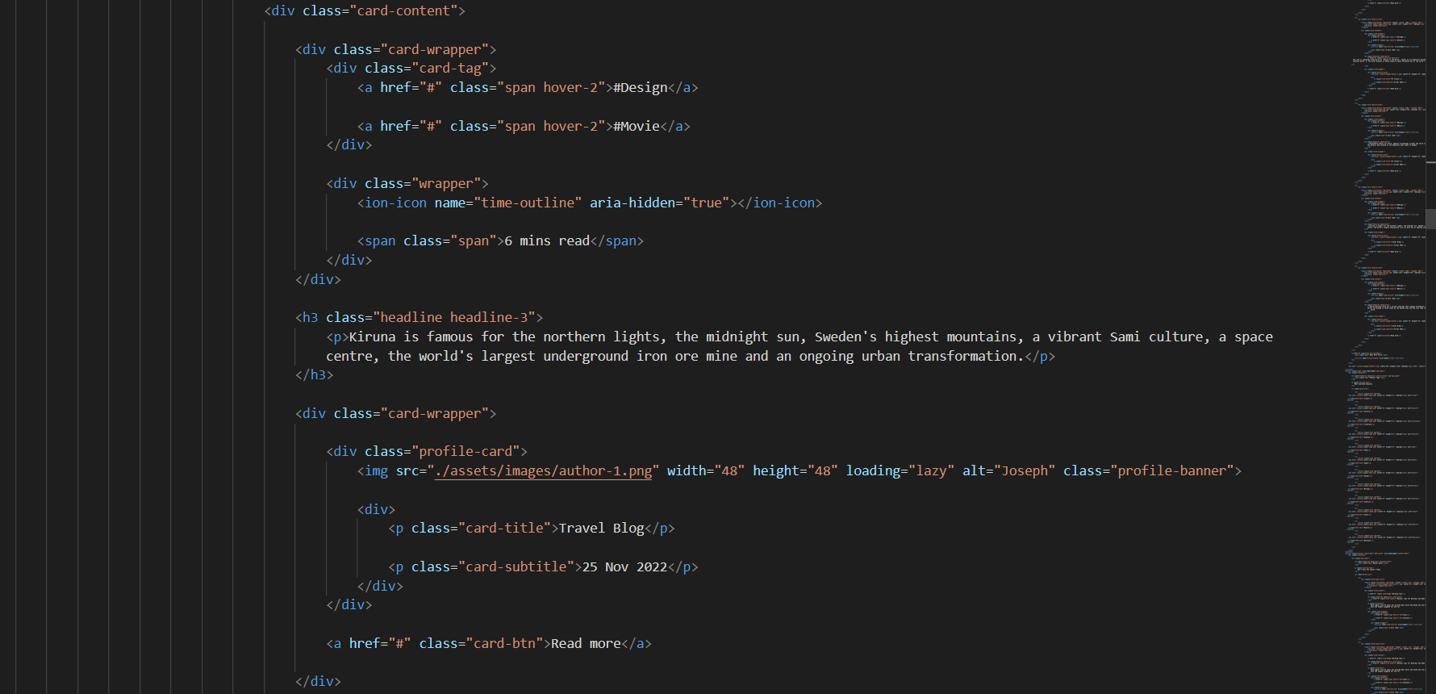

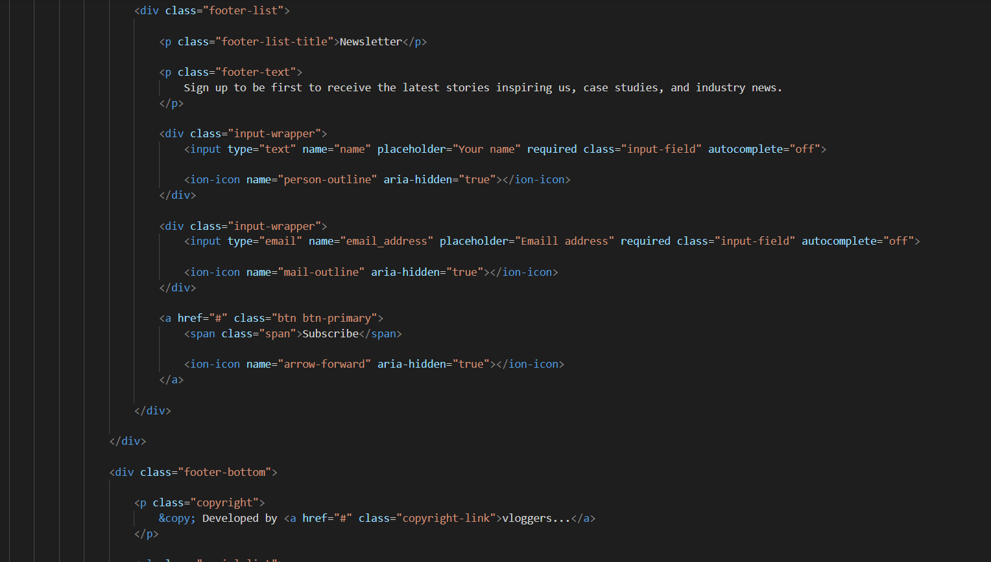

**4.CSS File**

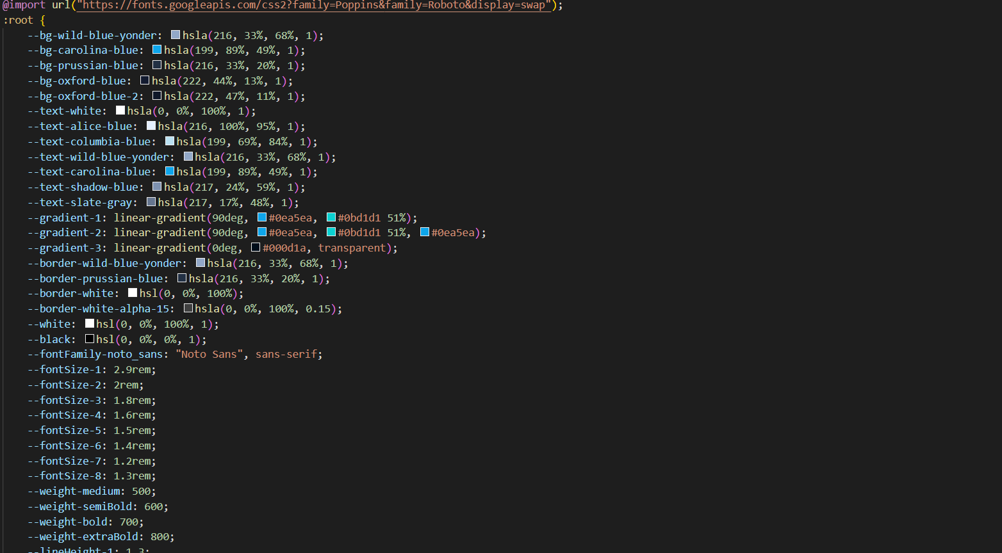

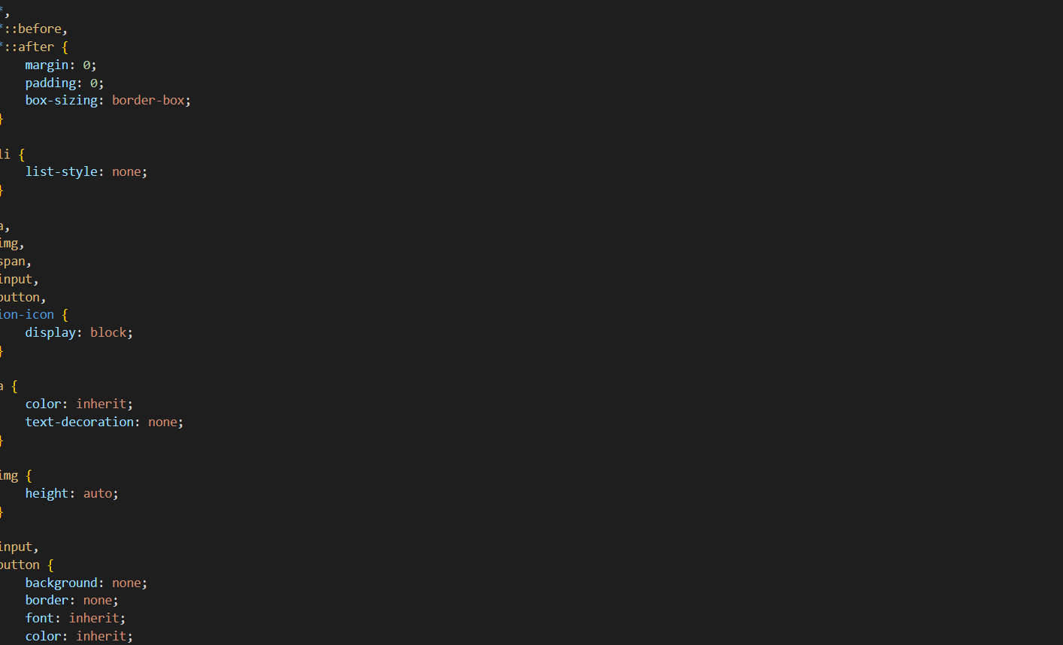

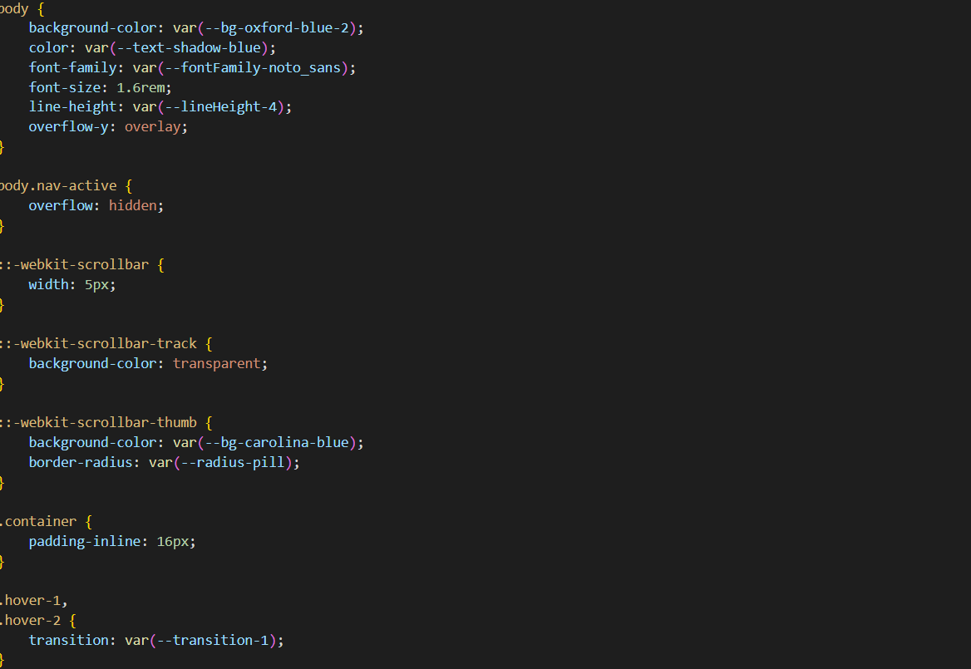

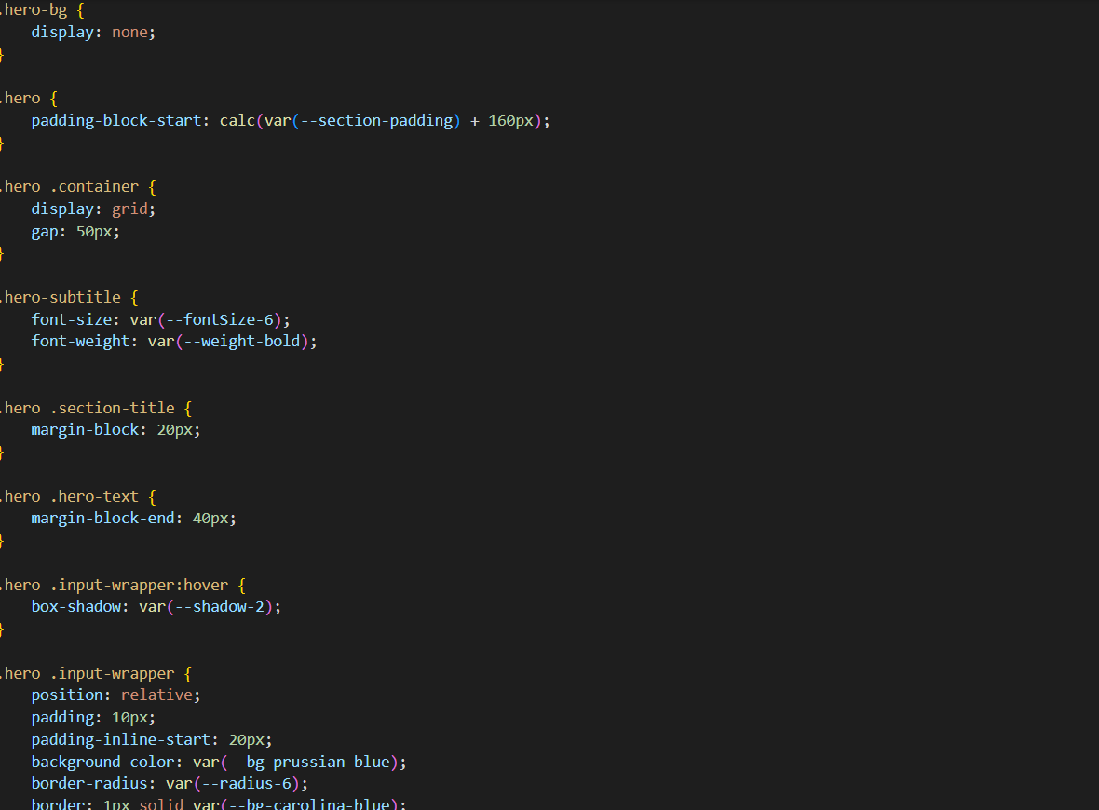

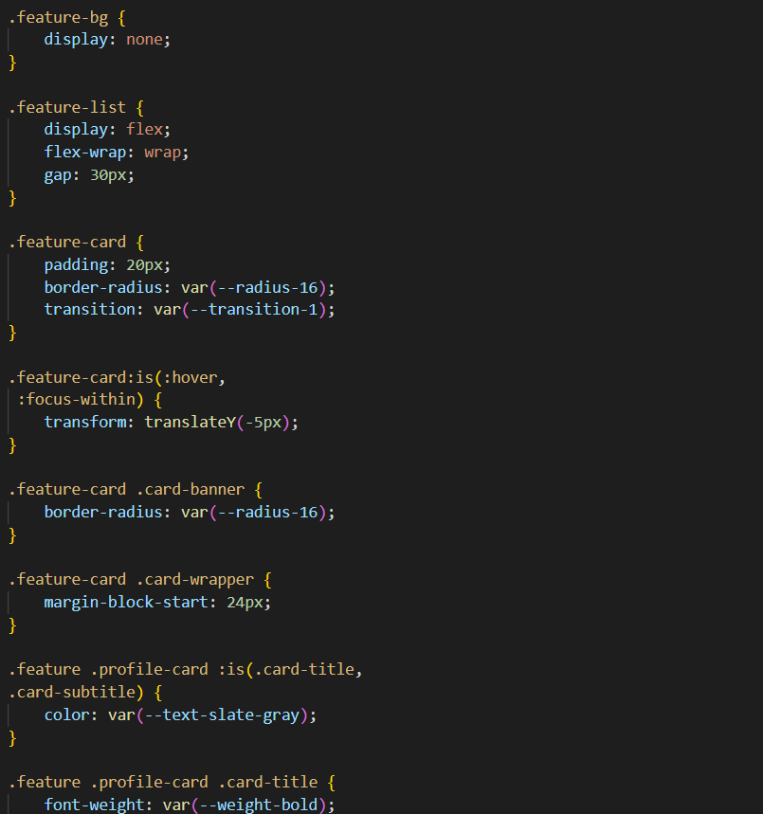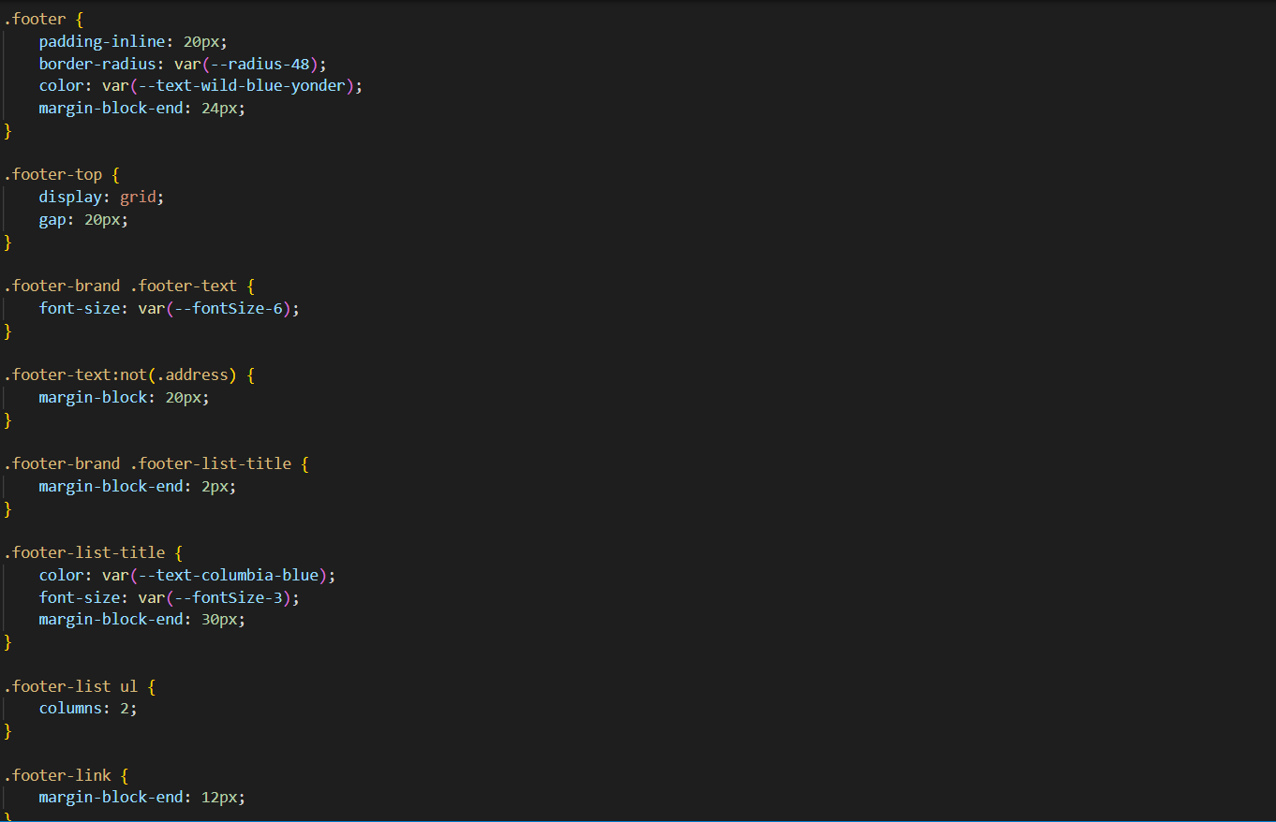

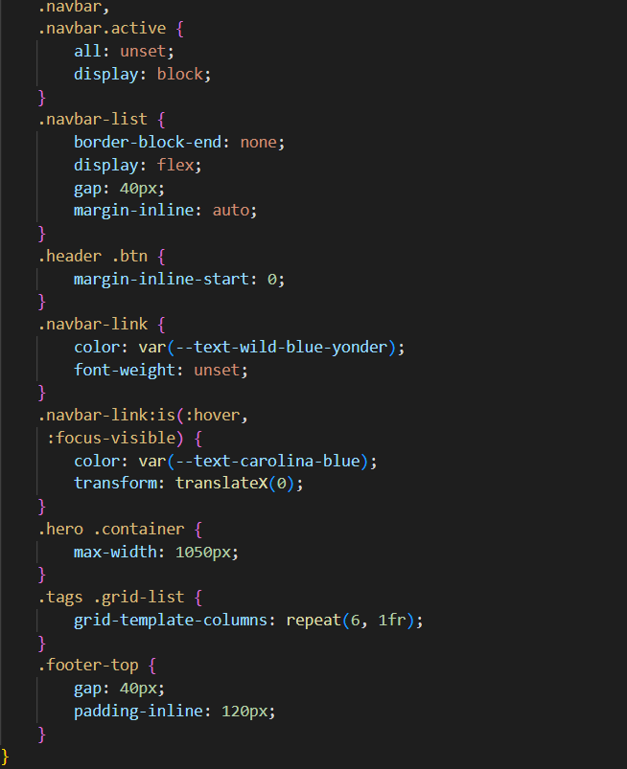

**SCREENSHOT:**

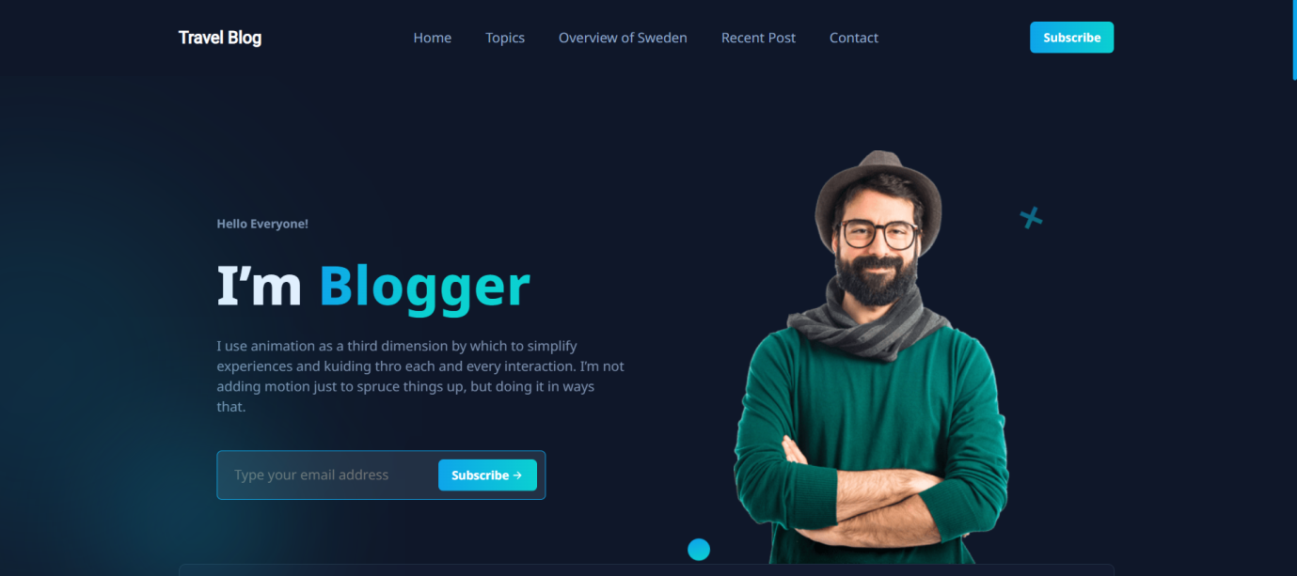

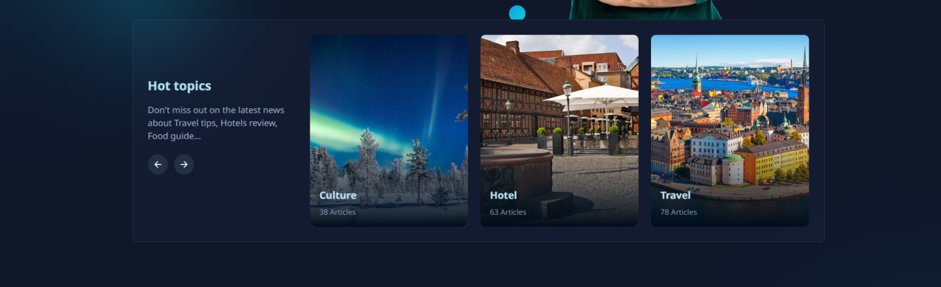

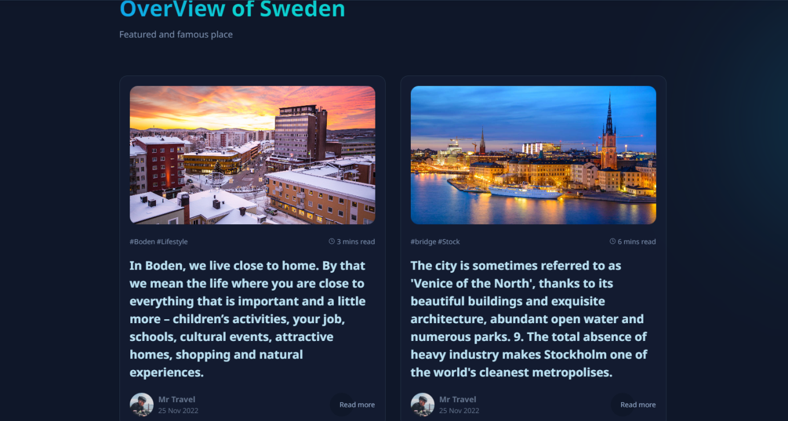

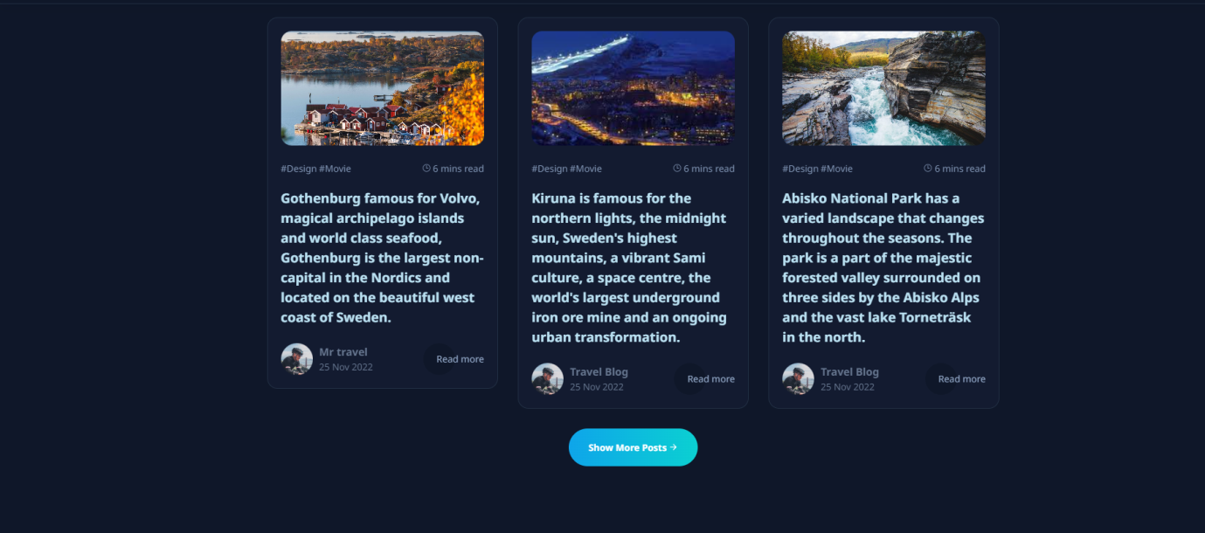

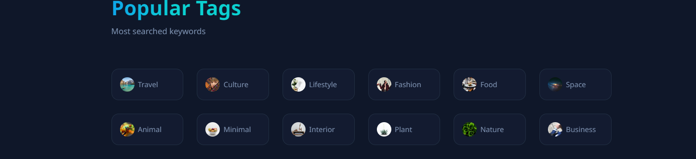

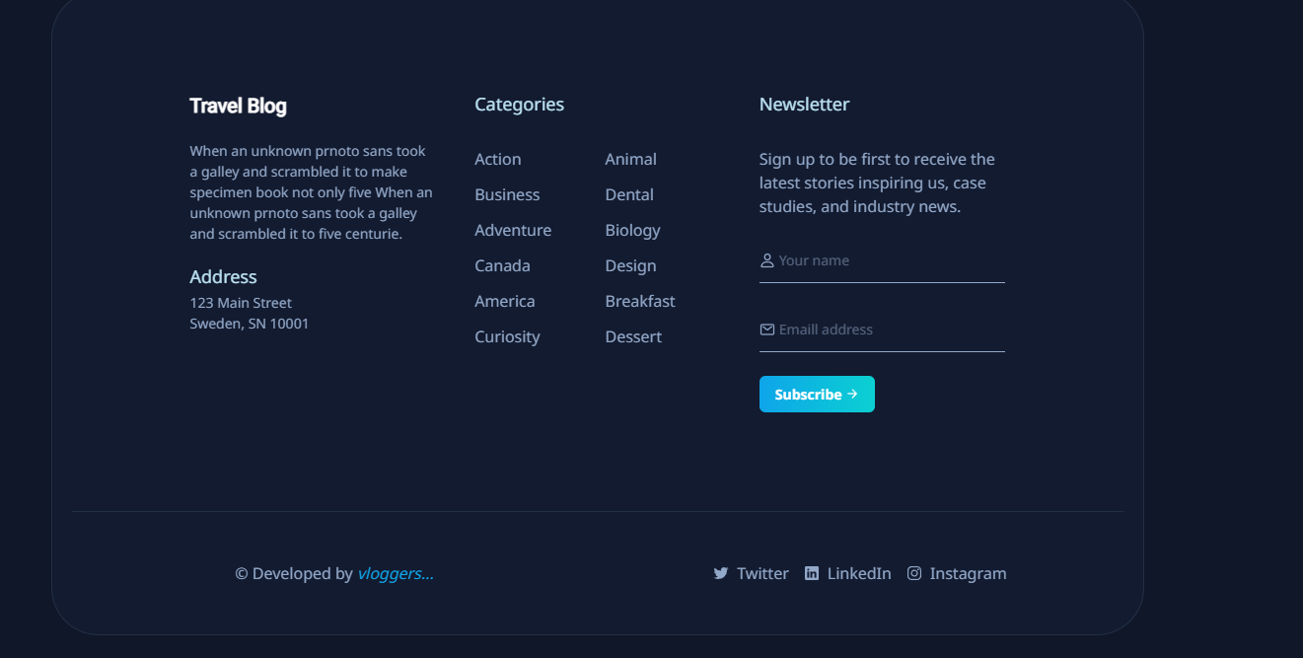

GITHUB REPOSITORY LINK:

https://logeshselvam07.github.io/phase-5-project-code/

**CONCLUSION**

Hosting your personal blog on IBM Cloud Static WebApps is a wise choice for bloggers looking for a reliable, scalable, and cost-effective hosting solution. It combines the ease of deployment with powerful features to enhance the performance, security, and customization of your blog. By automating deployment, securing your site, and leveraging the cloud's scalability, you can focus on what you do best – creating and sharing valuable content with your audience. With the support of a vibrant community and a wealth of learning opportunities, your blogging journey on this platform can be both productive and enriching.